Sticker generation through user input data.

1. Following Human Input to be captured in a different variable
2. MAWB NO: String 13 digits e.g. 235-2345-1234
3. HAWB No: String 12 digits e.g. MCL23100235
4. DESTINATION string 3 digits e.g. DAC, LHR
5. NO OF PKGS Numeric 5 digits e.g. 4000
6. Open following format kept in specific directory

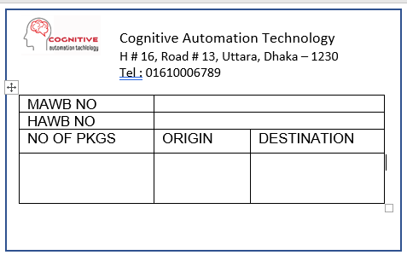

1. Insert data captured through human input

You’ve to use word application scope and find the place to insert the data captured in variable.

Use for each row to generate number of stickers. For example. In case of NO OF PKGS 10, fist sticker no of pkgs will be 01, then 01 and thus there will be 10 stickers to be generated.